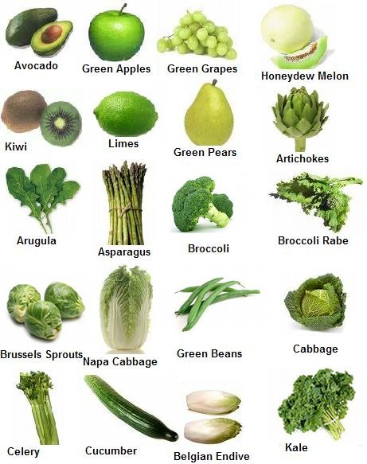
The Green for Scholars program brings green into the classroom and cafeteria to get scholars green. The program combines eating green fruits and vegetables and interactive and accessible environmental education for our scholars. CS Academy brings the school garden experience into classrooms and cafeterias with hands-on, experiential learning.
The program allows students and school staff to maintain the school green program by visiting fruit and vegetables markets twice per month during the Harvest Season. CS Academy provides a School Food Green Café once per month to share green fruits and vegetables in the cafeteria as a salad bars.

