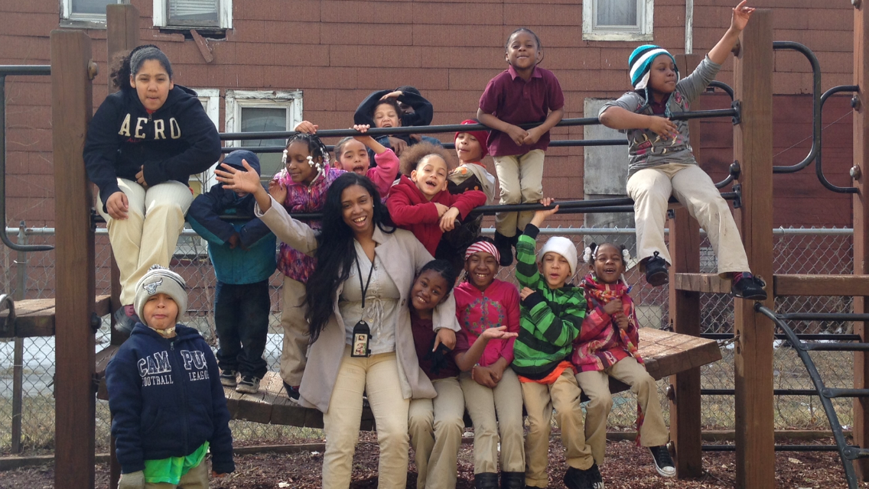
Our Cook for Kids program feed our scholars real food. CS Academy Chefs, trained food manager employees, work with students, parents, and staff to transform the school’s cafeteria menu and provide nutrition education to students.
Our daily goal is for scholars to return to class after lunch and recess ready to focus and learn. Our long-term goal is to teach scholars healthy habits that will last a lifetime.

